For contribution that occurs on the website.

There is a requirement to be able to contribute documents to the portal on the

portal. Normally we recommend that documents get contributed where it makes sense. For example if you have a section that pertains to monthly reports then you can have that section allow the user to contribute new monthly report documents.

This can be achieved by using dynamic lists. The steps to accomplish this are as follows:

-- create a dynamic list element

-- add the element to a region definition

-- add the region to a region template

-- add the region template in the region definition to a placeholder definition

-- create a placeholder mapping definition

-- insert a placeholder into a layout page, assign a data contribution file to the placeholder.

You should now have a content ID for the placeholder and the data contribution. These are the two elements that you make use of with openWCM. As Nitin has shown you how to use openWCM with these two parameters, construct a new portal page using that same method with the two new content IDs.

Below are some screenshots of the important items to remember when performing the above steps.

In the diagram below, select ‘New Item Settings’…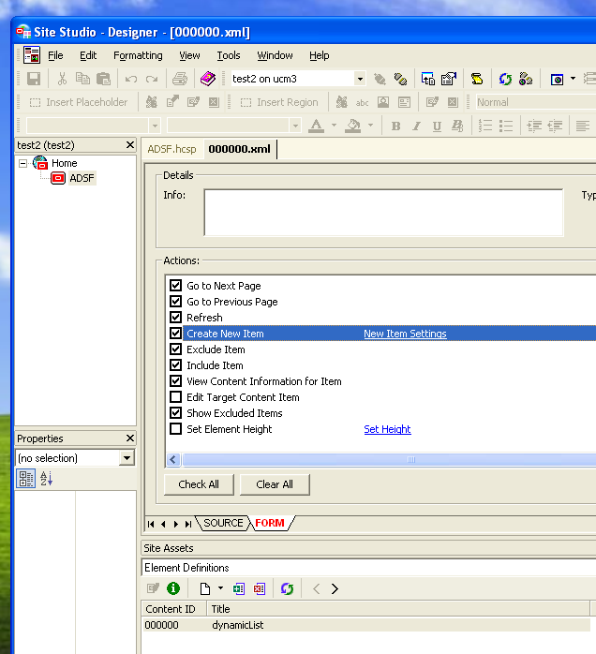

Make sure to check off: ‘Create new native document’ to allow users to contribute documents.

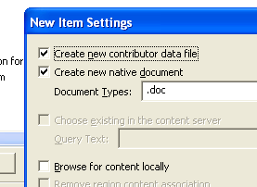

Then you will be able to add documents from the website as follows:

1. Enter contributor mode:

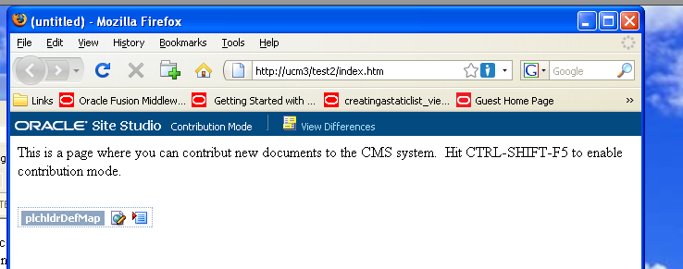

1. Select the document icon with the yellow star on top right. 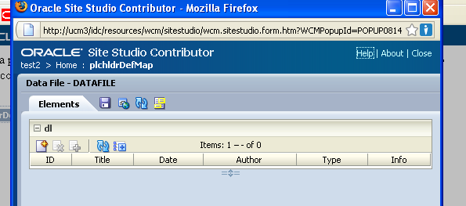
2. Choose ‘New native file’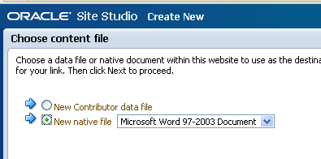
3. Finally, you will see the checkin form that has all the metadata as you would expect from the content server screen…including DCL metadata.

This method is ideally suited for contributing documents that you would have users download from the website to make use of on their desktop. For example these could be PDF report documents or Excel documents as an example. It is not recommended that native applications such as Microsoft Word be used to manage text and content that occurs directly on the website. To manage text that should occur directly on the website and not be downloaded as a PDF file for example we should use another technique that will be outlined.

This technique applies to the third use case that is to maintain a list of announcements. The best practice method to achieve this is to use

